JOB PORTAL

Restoring the Database from a .bak File
This project uses a SQL Server database, and to get started, you'll need to restore the database from a .bak (backup) file. Follow these steps:
- Obtain the .bak File:
  - Ensure you have a copy of the .bak file for this database.
  - Job-portal/JobPortal/JobPortal.bak at main · AJAY2-R/Job-portal
- Launch SQL Server Management Studio (SSMS):
  - Open SQL Server Management Studio, a graphical tool for managing SQL Server databases. If you don't have SSMS installed, you can download it from Microsoft's website.
- Connect to SQL Server:
  - Open SSMS and connect to your SQL Server instance where you want to restore the database. Ensure you have the necessary permissions to perform this operation.

- Restore the Database:
  - In SSMS, in the Object Explorer, right-click on "Databases."
  - Choose "Restore Database."

  - 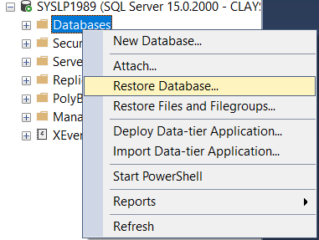
- Specify Source and Destination:
  - In the "General" section, select "Device" as the source.
  - Click the "..." button to browse for the .bak file.
  - Select your .bak backup file.
  - In the "To database" field, specify the name of the database you want to create or overwrite with the backup data.
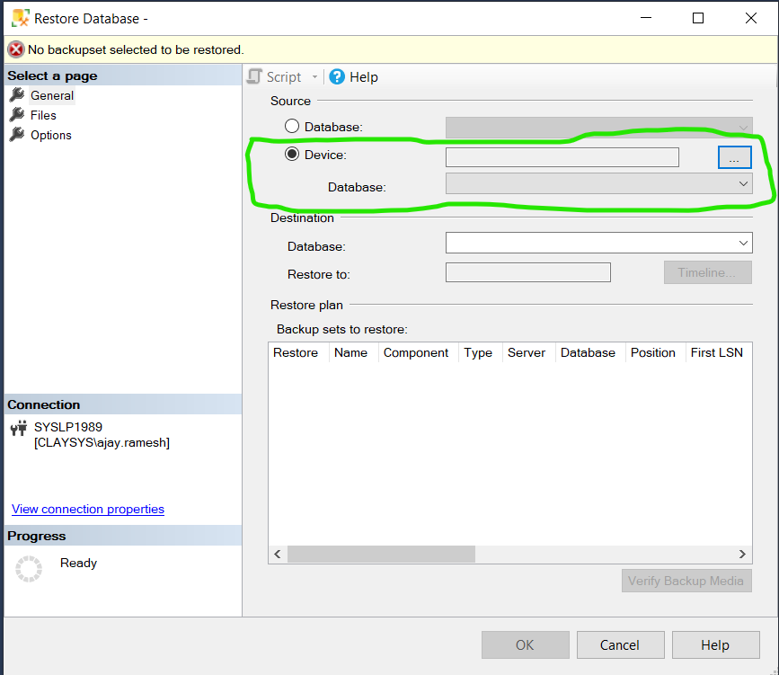

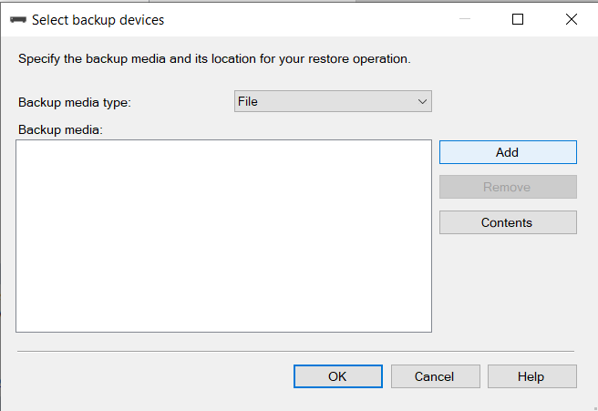
- Create an folder in LocalDisk C, and past the database backup in that folder
    - If backup file in any other location, its hard to add that file
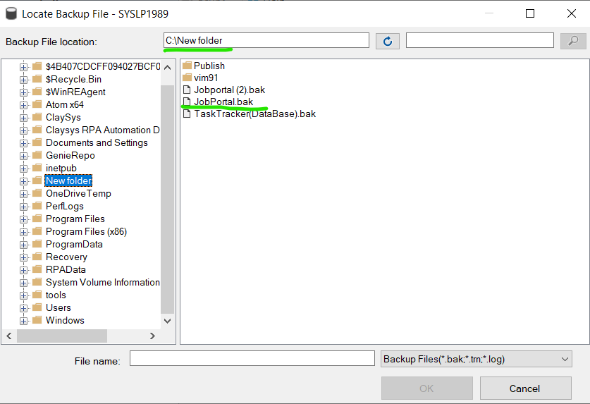
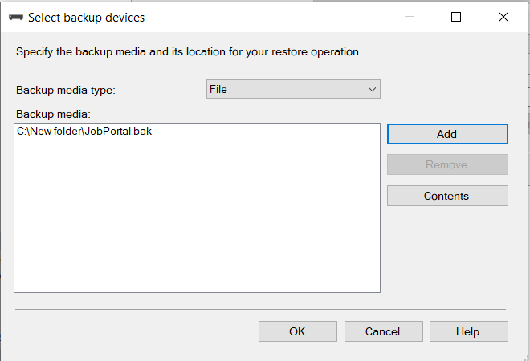

Click ‘OK’ after database added
If the database is loaded successfully, you will get similar window
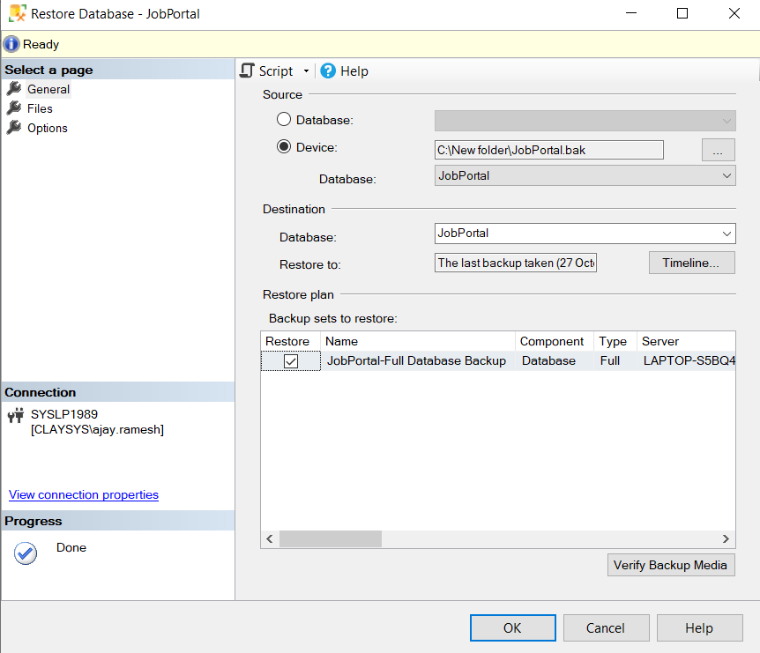
Click ‘OK’ , if you need another Database name you can customize that. You will get this message, If the databased added successfully

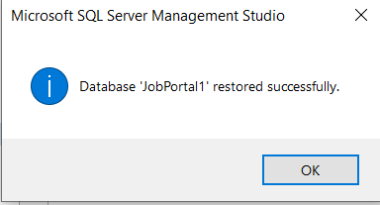
In Explorer, you can able to find the new database ,if you don’t find this click the refresh button
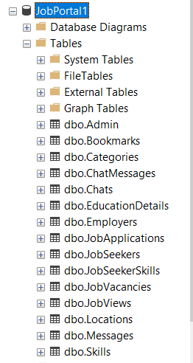

YOU HAVE SUCCESSFULLY ADDED DATABASE!!

CONFIGURE THE SOLUTION

Open the JobPortal.sln via Visual Studio

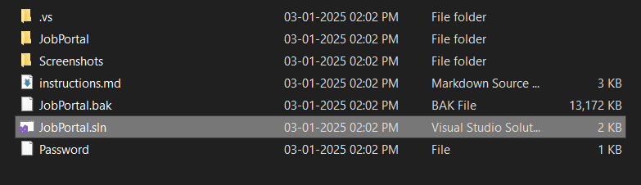

Open the web.config file after project is loaded
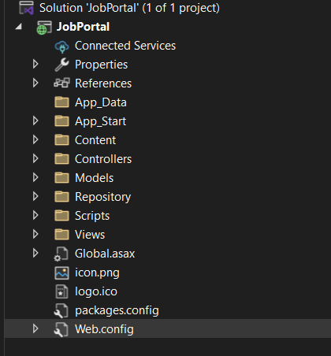
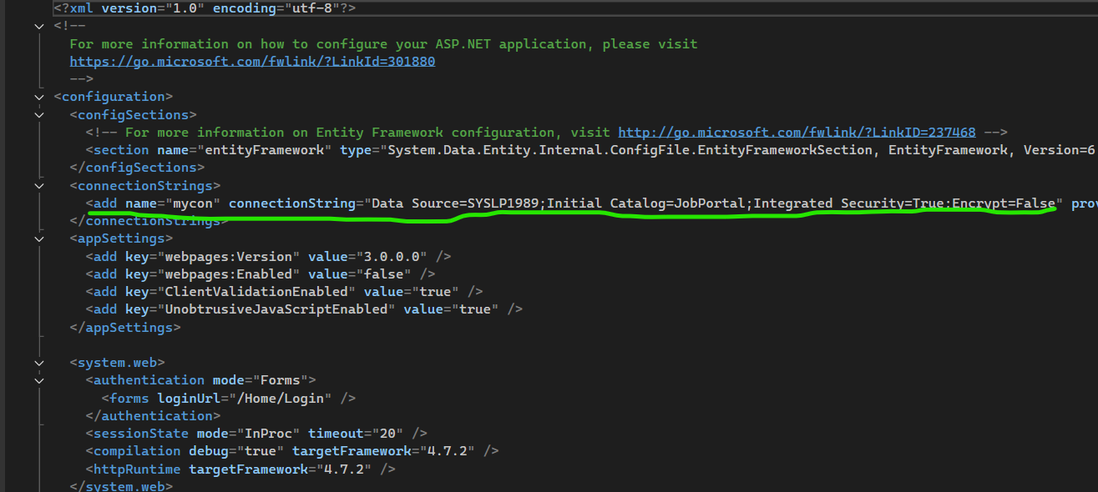
you need to modify this line
DataSource = ‘your sql server name’
Catalog = ‘JobPortal’ or custom name which you have provided during database restore

Explanation:
- <connectionStrings>:
This is the section in the configuration file where all database connection strings are defined.
- <add>:
This element represents a single connection string entry. Multiple <add> elements can be included if the application connects to different databases.
- Attributes in the <add> element:
  - name="mycon":
This is the name/key of the connection string. It is used in the code to reference this specific connection.
  - connectionString:
The actual connection details required to access the database. Let's break it down further:
    - Data Source=SYSLP1989:
The name of the server hosting the database. Here, SYSLP1989 is likely the server's network name or instance name.
    - Initial Catalog=JobPortal:
The name of the database you want to connect to, which in this case is JobPortal.
    - Integrated Security=True:
Specifies that Windows Authentication will be used for the database connection

    - instead of SQL Server Authentication. The application will use the Windows credentials of the user running the app.
    - Encrypt=False:
Indicates whether data transmitted between the application and database should be encrypted. Setting it to False disables encryption.
  - providerName="System.Data.SqlClient":
Specifies the .NET Framework data provider used for database communication. System.Data.SqlClient is the provider for SQL Server.

Start the project


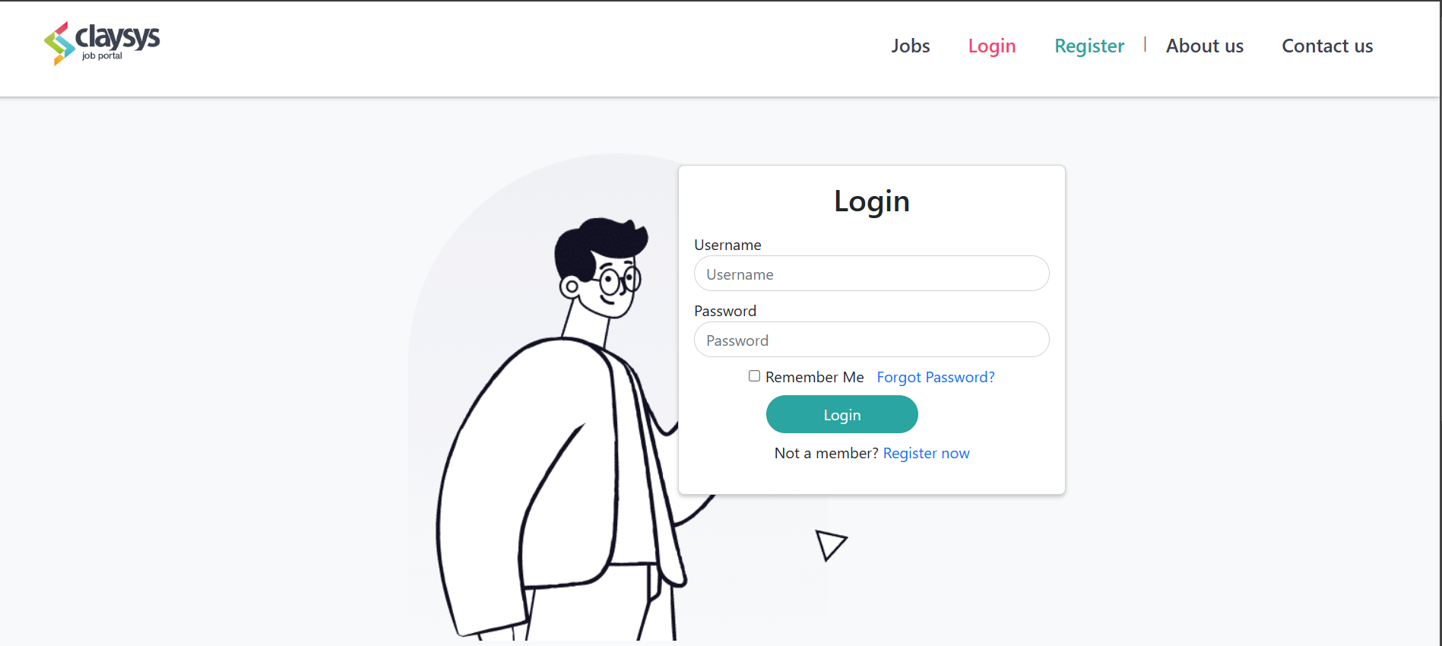
This project will have 3 users
1.Admin
2.Job Seeker
3.Employer
All three users will use the same login page

User credentials
Admin
1.
  - Username: admin
  - Password: Admin@123
2.
  - Username: admin2
  - Password: admin2
JobSeeker
1.
  - Username: gopu
  - Password: Gopu@123
2.
  - Username: john
  - Password: John@123
Employer
1.
  - Username: microsoft
  - Password: Microsoft@123
2.
  - Username: amazon
  - Password: Amazon@123

https://localhost:XXXX/Home/Jobs
You will not able to see any jobs , because old jobs will be not displayed after Deadline date,either you can add new job or modify existing jobs last date in database (table : JobVacancies)

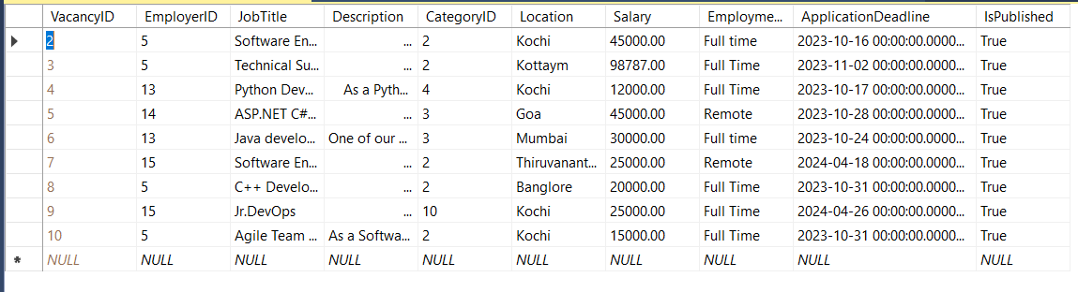
After changing the date ,you will able to see the jobs in the home page
